 

## ASSIGNMENT 1 FRONT SHEET

|  |  |  |  |
| --- | --- | --- | --- |
| **Qualification** | **BTEC Level 5 HND Diploma in Computing** | | |
| **Unit number and title** | Unit 06: Managing a Successful Computing Project | | |
| **Submission date** | June 12, 2019 | **Date Received 1st submission** |  |
| **Re-submission Date** |  | **Date Received 2nd submission** |  |
| **Student Name** | Huynh Thai Hieu | **Student ID** | GCD18314 |
| **Class** | GCD0821 | **Assessor name** |  |
| **Student declaration**  I certify that the assignment submission is entirely my own work and I fully understand the consequences of plagiarism. I understand that making a false declaration is a form of malpractice. | | | |
|  | | **Student’s signature** |  |

#### Grading grid

|  |  |  |  |  |  |  |
| --- | --- | --- | --- | --- | --- | --- |
| P1 | P2 | P3 | P4 | M1 | M2 | D1 |
|  |  |  |  |  |  |  |

 

#### Summative Feedback:  Resubmission Feedback:

**Grade: Assessor Signature: Date: Internal Verifier’s Comments:**

**IV Signature:**

 

## Seatek Recruitment Solutions ®

**PROJECT MANAGEMENT PLAN**

of

# VIRTUAL RECRUITMENT ASSISTANT:

**SRBot**

Huynh Thai Hieu Research and Development department, Seatek Recruitment Solutions ®

20 May 2019

**TABLE OF CONTENTS**

PROJECT CHARTER 2

INTRODUCTION 7

Project Aims 7

Project Objectives 7

PROJECT MANAGEMENT APPROACH & PROCESSING METHODOLOGY 8

PROJECT SCOPE 10

PROJECT MILESTONE LIST 10

PROJECT COMMUNICATION 12

Project communication matrix 12

Team structures 13

PROJECT SCHEDULE & WORK BREAKDOWN STRUCTURE 15

Work breakdown structure 15

Project schedule 16

Research and Planning phase 16

Construction phase 17

Delivery and maintenance phase 17

Project schedule management plan 18

Project schedule Activity estimation 18

Project schedule controlling 18

PROJECT COST MANAGEMENT 19

Project cost estimating 19

Human-resource cost estimating 19

Other required components cost estimating 20

Project cost management plan 20

PROJECT RISK MANAGEMENT 21

Project Risk matrix 21

Risk management plan 21

PROJECT QUALITATIVE & QUANTITATIVE RESEARCH 22

Project qualitative research 22

Project quantitative research 23

REFERENCES 26

### PROJECT CHARTER

|  |  |  |  |  |  |
| --- | --- | --- | --- | --- | --- |
| **1. General Project Information** | | | | | |
| **Project Name:** | | **Virtual Recruitment Assistant: SRBot** | | | |
| **Executive Sponsors:** | | **Chief Technology Officer – CTO of Seatek Recruitment Solutions** | | | |
| **Department Sponsor:** | | **Research and Development Department of Seatek Recruitment Solutions** | | | |
| **Impact of project:** | | Upgrade the company’s recruitment solution system into a far superior,  AI based system | | | |
| **2. Project Team** | | | | | |
|  | **Name** | | **Department** | **Telephone** | **E-mail** |
| **Project Manager:** | Huynh Thai Hieu | | Research and Development Department | +849055106  23 | [thaihieuhuynh1752@gmail.com](mailto:thaihieuhuynh1752@gmail.com) |
| **Team Members:** | Le Phuoc Anh Khoa | | Research and Development Department | +849354560  98 | [khoalpa2000@gmail.com](mailto:khoalpa2000@gmail.com) |
|  | Tran Le Bach Tung | | Research and Development Department | +849837877  87 | [tungtlb2000@gmail.com](mailto:tungtlb2000@gmail.com) |
|  | Tran Quang Huy | | Research and Development Department | +849077108  10 | [mifado95@gmail.com](mailto:mifado95@gmail.com) |
|  | Tran Ngoc Thanh | | Research and Development Department | +849332133  24 | [thanhtn99@gmail.com](mailto:thanhtn99@gmail.com) |
|  | Huynh Le Minh | | Research and Development Department | +849833287  77 | [minhhl99@gmail.com](mailto:minhhl99@gmail.com) |
|  | Nguyen Tuan Anh | | Research and Development Department | +849545677  68 | [anhnt95@gmail.com](mailto:anhnt95@gmail.com) |
|  | Nguyen Hoang Long | | Research and Development Department | +849554675  78 | [longnh2000@gmail.com](mailto:longnh2000@gmail.com) |

|  |  |  |  |  |
| --- | --- | --- | --- | --- |
|  | Duong Nguyen Quynh Giang | Customer Representative Department | +849433455  43 | [giangdnq97@gmail.com](mailto:giangdnq97@gmail.com) |
|  | Ho Ngoc Tram Anh | Customer Representative Department | +849223944  98 | [anhhnt96@gmail.com](mailto:anhhnt96@gmail.com) |
|  | Thai Van Hoang Huy | Recruitment Solution Department | +849227877  67 | [huytvh99@gmail.com](mailto:huytvh99@gmail.com) |
|  | Vo Thanh Duc | Recruitment Solution Department | +849665135  43 | [ducvt2000@gmail.com](mailto:ducvt2000@gmail.com) |
|  | Ho Hoang Thien Minh | Recruitment Solution Department | +849887765  54 | [minhhht89@gmail.com](mailto:minhhht89@gmail.com) |
| **3. Stakeholders *(e.g., those with a significant interest in or who will be significantly affected by this project)*** | | | | |
| Nguyen Quang Tung – CEO of Seatek Recruitment Solutions | | | | |
| Le Thi Ngoc Anh – Head Manager of Recruitment Solution Department – Seatek Recruitment Solutions | | | | |
| Truong My Quyen – Head Manager of Customer Representative Department – Seatek Recruitment Solutions | | | | |
| Jobster.io from KE Solutions (Canada) – The world’s first AI-informed career advisory platform | | | | |
|  | | | | |
| **4. Project Scope Statement** | | | | |
| **Project Purpose / Business Justification** | | | | |
| The development of **Project: Virtual Recruitment Assistant: SRBot** is in purpose of upgrading current human-based recruitment solution system into a far superior and efficient system by implementing AI technologies. | | | | |
| **Objectives (in business terms)** | | | | |
| * Reduce the time-frame of resume scanning process by 4 times * Reduce the cost of hiring employees to scan and analyze resumes * Increase applicants (employees looking for a job) amount * Increase quality of recruiting solutions by providing suggestions through AI’s CV-analysis | | | | |

|  |
| --- |
| **Deliverables** |
| * Improved resume scanning & filtering process * Improved the success rate of hiring suitable employee based on auto-data-analyzed suggestions * Upgraded current human-based system into advanced, AI technology-implemented system |
| **Scope** |
| This project is for the creation (including the planning, design, development, testing and transition) of an AI-based recruitment solution system that will advance current human-based recruitment solution system of the company into a whole new level. This system will have a UI as an virtual assistant application that provide following features:   * CV, Portforlio scanning & analyzing * Self-learning about the customer company’s business information, culture and their needs * Ranking applicants based on comparison between the applicant’s data and the customer company’s data * Provide the calculated suitable rate of both applicant and customer company |
| **Project Milestones** |
| * **Inception phase** (Project Idea planning, Stakeholders identification, team member filtering):   *Start*: 20 May 2019 – *End:* 2 June 2019 – *Status:* **Done**   * **Planning phase** (Concept planning; Cost, Timeframe, Case studies, Quantitative & Qualitative researches; Technology identifications; Risk identifications)   *Start:* 3 June 2019 – *End:* 30 June 2019 – *Status:* **Doing**   * **Construction phase**   *Start:* 1 July 2019 – *End:* 1 December 2019 – *Status:* **Pending**   * **Delivery & maintenance phase**   *Start:* 2 December 2019 – *End:* 2 December 2020 – *Status:* **Pending** |

|  |  |  |  |
| --- | --- | --- | --- |
| **Major Known Risks (including significant Assumptions)** | | | |
|  | **Risk** | **Risk Rating (Hi, Med, Lo)** |  |
|  | Lack of stakeholder’s involvements | **High** |  |
|  | Team member’s attitude & abilities | **Medium** |  |
|  | Costs during development got underestimated | **High** |  |
| **Constraints** | | | |
| * The interactions, understanding and working together ability between members from related departments * The interaction and monitorization from stakeholders to the project, as well as their understanding about the characteristics of the project | | | |
| **External Dependencies** | | | |
| This project success depends on coordination between the project team and:   * Jobster.io platform developer team (for technology exchanging and mentoring) * Recruitment Solution Department * Customer Representative Department | | | |
| **5. Communication Strategy** | | | |
| **Communication method**:   * Updating project progress report to the Executive Sponsor every Friday afternoon * Have a meeting that consist every stakeholders each month and in the end of each project milestone   **Frequency of status reporting**:   * One fixed team member will be responsible for project documenting and reporting every weekend | | | |

|  |  |  |  |
| --- | --- | --- | --- |
| **6. Sign-off** | | | |
|  | **Name** | **Signature** | **Date (MM/DD/YYY Y)** |
| **Executive Sponsor** | Huynh Xuan Hoang |  |  |
| **Department Sponsor** | Huynh Thai Hoa |  |  |
| **Project Manager** | Huynh Thai Hieu |  |  |
| **7. Notes** | | | |
|  | | | |

### INTRODUCTION

Seatek Recruitment Solutions (SRS) has been successful in building a solid reputation to become one of the nation’s most trusted Search Recruitment Specialists, by providing the best personal service and exceptional quality to both clients and candidates involved.

With over 25 years of proven experience sourcing candidates in various fields and unique professions nationally, now with the expansion of AI technologies, SRS believes that new technological developments, such as Project: Virtual Recruitment Assistant: SRBot will enable our team to develop a recruitment solution system far superior to what is currently available.

PROJECT AIMS

Project: Virtual Recruitment Assistant: SRBot aims to:

* Automate all time-consuming tasks such as: resume screening and interview scheduling
* Provide candidates sourcing based on company’s needs
* Improve quality of hire by providing suitability predictions based on candidate’s data
* Reduce bias PROJECT OBJECTIVES

The development of this project is in order to satisfy following objectives:

* Reduce the time-frame of resume scanning process by 4 times
* Reduce the cost of hiring employees to scan and analyze resumes
* Increase applicants (employees looking for a job) amount
* Increase quality of recruiting solutions by providing suggestions through AI’s CV- analysis

### PROJECT MANAGEMENT APPROACH & PROCESSING METHODOLOGY

In order to accomplish this project successfully, **Agile methodology** will be implemented to perform the project management approach.

**Agile methodology** is a type of process where demands and solutions evolve through the collaborative effort of self-organizing and cross-functional teams and their customers, made up of four fundamental values and 12 key principles:

#### Values:

**Principles:**

* Individuals and interactions over processes and tools
* Working software over comprehensive documentation
* Customer collaboration over contract negotiation
* Responding to change over following a plan
* Customer satisfaction through early and continuous software delivery
* Accommodate changing requirements throughout the development

process

* + Frequent delivery of working software
  + Collaboration between the business stakeholders and developers throughout the project
  + Support, trust and motivate the people involved
  + Enable face-to-face interactions
  + Working software is the primary measure of progress
  + Agile processes to support a consistent development pace
  + Attention to technical detail and design enhances agility
  + Simplicity
  + Self-organizing teams encourage great architectures, requirements and designs
  + Regular reflections on how to become more effective

This **Agile methodology** allows the Project Manager and other stakeholders to assess and examine the direction of the project during its life cycle. The Project Manager, Huynh Thai Hieu, has the overall authority and responsibility for managing and executing this project according to the Project Development Plan.

The project team will consist of personnel from:

* Research and Development Department: 7 members
* Customer Representative Department: 2 members
* Recruitment Solutions Department: 3 members

Because of the complexity, as well as the uncertainty of this AI technology-implementation project, **Agile methodology**, with six main deliverables that track progress and create: product vision statement, product roadmap, product backlog, release plan, sprint backlog

and increment, will establishes itself as a management methodology that places an

emphasis on collaboration, reducing risks and made a high product quality, therefore, higher customer satisfaction.

### PROJECT SCOPE

The scope of SRS’s SRBot project includes the planning, design, development, testing and transition of the SRBot: Virtual Recruitment Assistant software package. This AI-based software will meet or exceed organizational software standards and additional requirements established in the Project Charter. The scope of this project also includes completion of all documentation, manuals and training aids to be used in conjunction with the software, as well as the collaboration and satisfaction from stakeholders and customer companies.

Project completion will occur when the software and documentation package has been successfully executed and transitioned to SRS’s Recruitment Solution Department for application with other customer companies that looking for recruitment solutions.

All SRBot project work will be performed internally and no portion of this project will be outsourced. The scope of this project may include changes in customer’s requirements to do future software updates.

### PROJECT MILESTONE LIST

The below chart lists the major milestones for the SRBot – Virtual Recruitment Assistant project. This chart is comprised only of major project milestones. There may be smaller milestones which are not included on this following chart but are included in the Project Schedule and Work Breakdown Structure (WBS). If there are any scheduling delays which may impact a milestone or delivery date, stakeholders and the project manager must be notified immediately so proactive measures may be taken to mitigate slips in dates.

Any approved changes to these milestones or dates will be communicated to the project team & stakeholders by the project manager.

|  |  |  |  |
| --- | --- | --- | --- |
| **Milestone** | **Description** | **Begin date** | **Status** |
| Complete  **Inception Phase** | Complete Project Idea planning | 20 May  2019 | **Done** |
| Complete Stakeholders identification | 20 May  2019 |
| Complete Team member filtering | 20 May  2019 |
| Complete **Planning Phase** | Complete Project concept planning | 2 June  2019 | **Doing** |

|  |  |  |  |
| --- | --- | --- | --- |
|  | Complete Qualitative & Quantitative research | 2 June  2019 |  |
| Complete Case studies & technology identification | 7 June  2019 |
| Complete Work Breakdown Structure & Project Schedule planning | 24 June  2019 |
| Complete Cost & Timeframe planning | 26 June  2019 |
| Complete  **Construction Phase** | Complete SRBot’s Back-end functions | 1 July 2019 | **Pending** |
| Complete SRBot’s Front-end interface | 1 October  2019 |
| Complete SRBot Testing and Debugging | 21 October  2019 |
| Complete **Delivery Phase** | Complete SRBot system and documentations | 2  December 2019 | **Pending** |
| Complete transitioning SRBot system to Recruitment Solution Department to operate | 10  December 2019 |
| Complete Apple App Store & Android CH Play client-side application delivery | 10  December 2019 |
| Complete **Maintenance Phase** | Complete SRBot status, performance and quality tracking | 20  December 2019 | **Pending** |
| Complete system updating (if necessary) | 20  December 2019 |

### PROJECT COMMUNICATION

PROJECT COMMUNICATION MATRIX

|  |  |  |  |  |  |  |
| --- | --- | --- | --- | --- | --- | --- |
| **Communication type** | **Description** | **Update frequency** | **Format** | **Participants/ Distribution** | **Deliverables** | **Owner** |
| **Weekly status report** | Email  summary of project status | Weekly | Report via  Email | Project Sponsor, Developer team and  stakeholders | Status report | Project Manager |
| **Weekly project team meeting** | Meeting to review action register and  status | Weekly | In  person | Project team | Updated  Action register | Project Manager |
| **Project**  **monthly review** | Present  metrics and status to  team and  sponsor | Monthly | In  person | Project sponsor, Developer team and  stakeholders | Status and Metrics  presentation | Project Manager |
| **Project’s technical function review** | Review of any technical  designs or work associated with the  project | As needed | In  person | Project sponsor, Developer team and stakeholders | Technical Design Package | Project Manager |
| **Project Gate review** | Present closeout of project phases and kick-off next  phase | As  needed | In  person | Project sponsor, Developer team and stakeholders | Phase  completion report and  Phase kick-off | Project Manager |

TEAM STRUCTURES

#### Developer Team

|  |  |  |  |  |
| --- | --- | --- | --- | --- |
| **Name** | **Title** | **Role** | **Email** | **Phone** |
| **Huynh Thai Hieu** | Project Manager | Project Manager and  Technical  advisor | [thaihieuhuynh1752@gmail.com](mailto:thaihieuhuynh1752@gmail.com) | +84905510623 |
| **Le Phuoc Anh Khoa** | Senior Developer | SQL, Java developer | [khoalpa2000@gmail.com](mailto:khoalpa2000@gmail.com) | +84935456098 |
| **Tran Le**  **Bach Tung** | Senior Developer | SQL, Java developer | [tungtlb2000@gmail.com](mailto:tungtlb2000@gmail.com) | +84983787787 |
| **Tran Quang Huy** | Senior Developer | Python, Java developer | [mifado95@gmail.com](mailto:mifado95@gmail.com) | +84907710810 |
| **Tran Ngoc Thanh** | Senior Developer | Python,  ReactJS developer | [thanhtn95@gmail.com](mailto:thanhtn95@gmail.com) | +84933213324 |
| **Huynh Le Minh** | Senior Developer | Java, ReactJS developer | [minhhl99@gmail.com](mailto:minhhl99@gmail.com) | +84983328777 |
| **Nguyen**  **Hoang Long** | Developer | Java  developer | [longnh2000@gmail.com](mailto:longnh2000@gmail.com) | +84955467578 |
| **Nguyen Tuan Anh** | Senior  developer | Java  developer | [anhnt95@gmail.com](mailto:anhnt95@gmail.com) | +84954567768 |

**Research Team**

|  |  |  |  |  |
| --- | --- | --- | --- | --- |
| **Name** | **Title** | **Role** | **Email** | **Phone** |
| **Huynh Thai Hieu** | Project Manager | Project Manager and Technical  advisor | [thaihieuhuynh1752@gmail.com](mailto:thaihieuhuynh1752@gmail.com) | +84905510623 |
| **Duong Nguyen Quynh Giang** | Customer  Representative Officer | Customer needs  researcher | [giangdnq97@gmail.com](mailto:giangdnq97@gmail.com) | +84943345543 |

|  |  |  |  |  |
| --- | --- | --- | --- | --- |
| **Name** | **Title** | **Role** | **Email** | **Phone** |
| **Ho Ngoc Tram Anh** | Customer  Representative Officer | Applicant needs  researcher | [anhhnt96@gmail.com](mailto:anhhnt96@gmail.com) | +84922394498 |
| **Thai Van Hoang Huy** | Recruitment Solution Officer | Recruitment system  requirements  researcher | [huytvh99@gmail.com](mailto:huytvh99@gmail.com) | +84966513543 |
| **Vo Thanh Duc** | Recruitment Solution Officer | Recruitment system  requirements  researcher | [ducvt2000@gmail.com](mailto:ducvt2000@gmail.com) | +84966513543 |
| **Ho Hoang Thien Minh** | Recruitment Solution Officer | Recruitment system  requirements  researcher | [Minhhht89@gmail.com](mailto:Minhhht89@gmail.com) | +84988776554 |

### PROJECT SCHEDULE & WORK BREAKDOWN STRUCTURE

WORK BREAKDOWN STRUCTURE

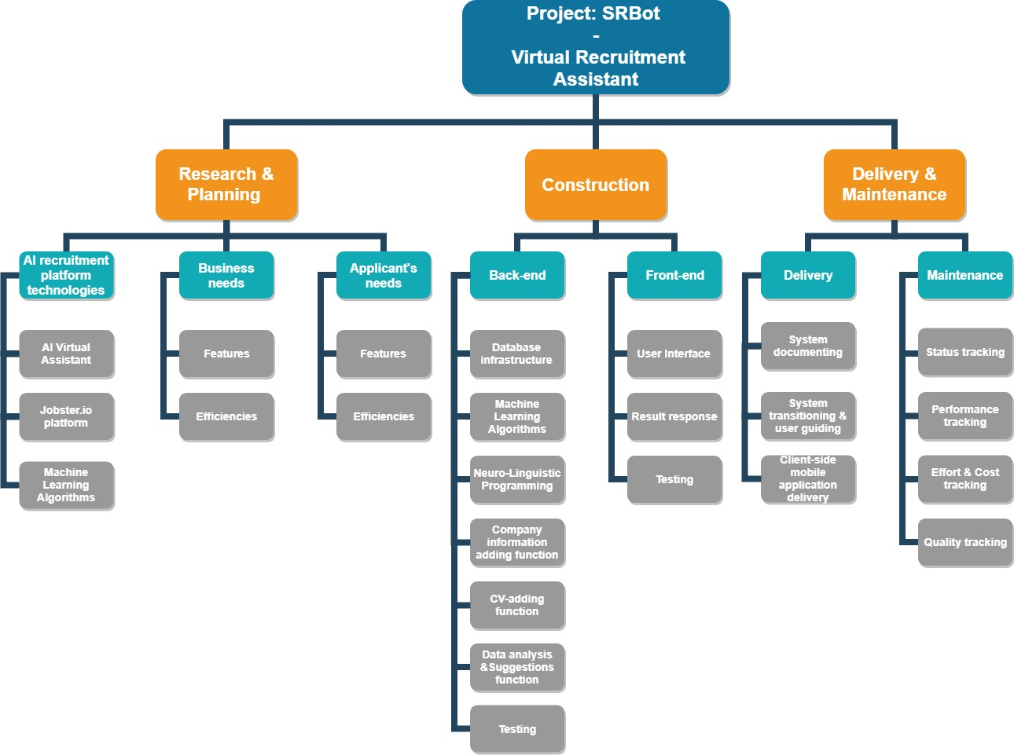

**Figure 1.** Project: SRBot’s Work Breakdown Structure

The WBS for the SRBot Project is comprised of 3 work packages represents 3 main phases of the development process, which are Research & Planning phase, Construction phase and Delivery & Maintenance phase. In order to assign those work to team member, following Gantt Chart in next section will represents as the Project Schedule management.

PROJECT SCHEDULE

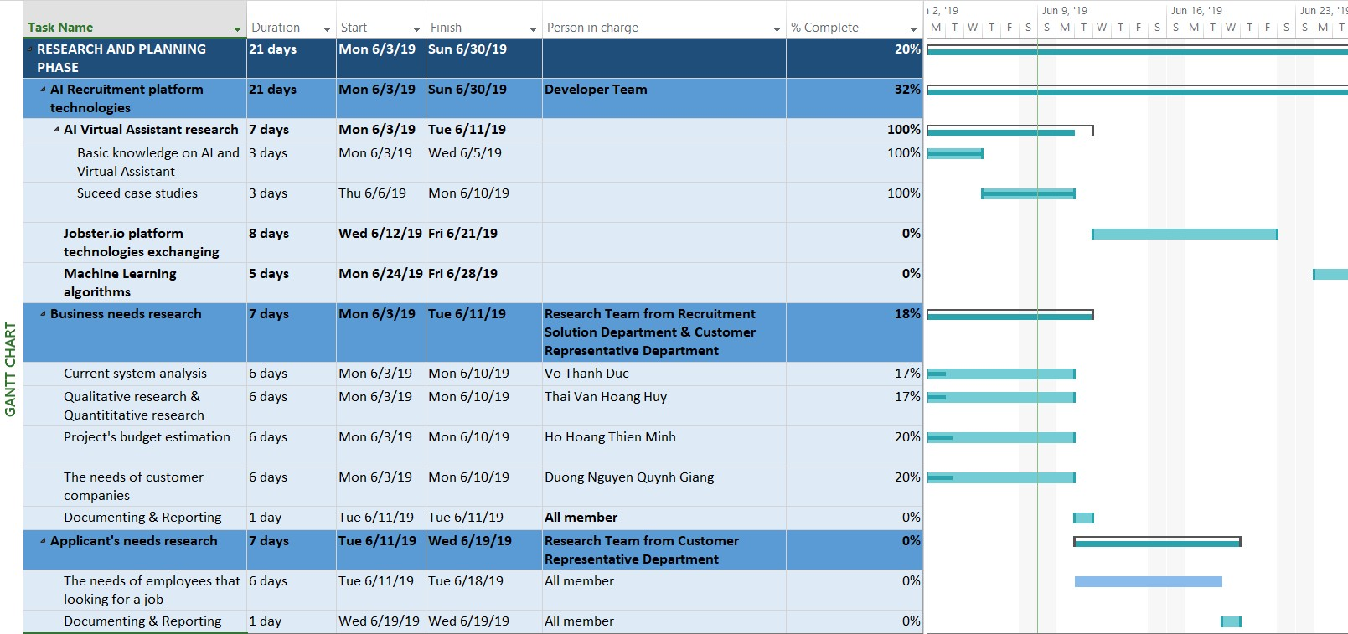RESEARCH AND PLANNING PHASE

**Figure 2.** Project Schedule for Research and Planning phase

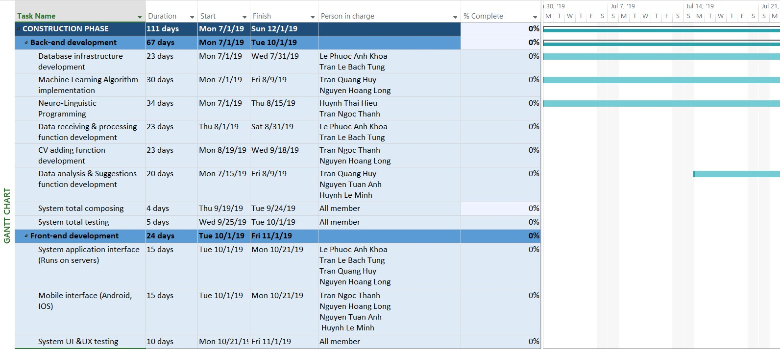CONSTRUCTION PHASE

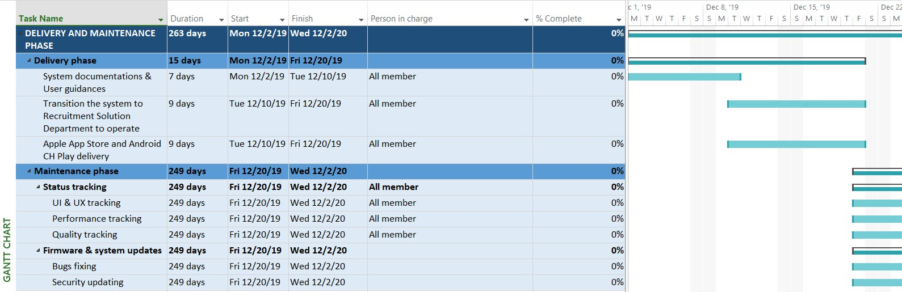**Figure 3.** Project Schedule for Construction Phase DELIVERY AND MAINTENANCE PHASE

**Figure 4.** Project Schedule for Delivery and Maintenance Phase

PROJECT SCHEDULE MANAGEMENT PLAN PROJECT SCHEDULE ACTIVITY ESTIMATION

The SRBot Project Schedule activity estimation method is **Bottom-up estimating**. Since the duration of entire project cannot be estimated with a reasonable degree of confidence, each of the work within the project that got described in the WBS will be estimated and then aggregated into a total quantity for each of the activity’s durations.

Moreover, with the help from Developer team of Jobster.io platform for technology mentoring, the SRBot Project Schedule can also be considered as using **Expert judgement** method.

PROJECT SCHEDULE CONTROLLING

In order to control the activity schedule of SRBot Project that fits all the requirements of timeframe, if the project falls behind the schedule and needs to catch up, the technique applied would be **Crashing schedule compression**.

Crashing analyzes and categorizes activities based on the lowest crash cost per unit time, allowing the team working of the project to identify the activities that will be able to deliver the most value at the least incremental cost. When the crashing approach is used, any additional costs associated with rushing the project will be reviewed by stakeholders, against the possible benefits of completing the project within a shorter time span.

### PROJECT COST MANAGEMENT

PROJECT COST ESTIMATING

HUMAN-RESOURCE COST ESTIMATING

|  |  |  |  |  |  |
| --- | --- | --- | --- | --- | --- |
| **Phase** | **Name of the process** | **Amount of member participated** | **Work hours** | **Cost/hour** | **Total** |
| Research and Planning | AI Virtual Assistant research | 8 members of Developer Team | 168 hours | $10 | $13,440 |
|  | Jobster.io platform  technologies exchange  training |  |  |  |  |
|  | Machine Learning algorithms  research |  |  |  |  |
|  | Business needs research | 6 members of Research Team | 56 hours | $8 | $2,688 |
|  | Applicant needs research | 2 members of Research Team | 56 hours | $8 | $896 |
|  |  |  |  | **Subtotal:** | **$17,024** |
| Construction | Back-end  development | 8 members of  Developer Team (6 Seniors & 2 Juniors) | 536 hours | $15 (Senior developer) | $48,240 |
|  | Front-end  development |  | $13 (Junior Developer) | $13,936 |
|  |  |  |  | **Subtotal:** | **$62,176** |
| Delivery and Maintenance | Delivery | 8 members of  Developer Team + 6 members of Research Team (from  Recruitment Solution  Dept.) | 120 hours | $8 | $13,440 |
|  | Maintenance | 83 hours | $5 | $5,810 |
|  |  |  |  | **Subtotal:** | **$19,250** |
|  |  | **TOTAL** |  |  | **$98,450** |

OTHER REQUIRED COMPONENTS COST ESTIMATING

|  |  |  |  |  |
| --- | --- | --- | --- | --- |
| **Item** | **Model** | **Quantity** | **Cost/ unit** | **Total** |
| Swervers | Dell PowerEdge R620 Server 2X 2.90Ghz E5-2690 8C 384GB 8X  512GB SSD  OS: Ubuntu Server 2016 | 4 | $700 | $2,800 |

PROJECT COST MANAGEMENT PLAN

The Project Manager will be responsible for managing and reporting on the project’s cost throughout the duration of the project.

For the SRBot Project, control accounts will be created at the fourth level of the WBS which is where all costs and performance will be managed and tracked. Financial performance of the SRBot Project will be measured through earned value calculations pertaining to the project’s cost accounts. Work started on work packages will grant that work package with 50% credit, whereas the remaining 50% is credited upon completion of all work defined in that work package. Costs may be rounded to the nearest dollar and work hours rounded to the nearest whole hour.

Cost Performance Index (CPI) and Schedule Performance Index (SPI) will be reported on a monthly basis by the Project Manager to the Project Sponsor & Stakeholders:

* Variances of 10% or +/-0.1 in the cost and schedule performance indexes will change the status of the cost to yellow or cautionary.
* Variances of 20%, or +/- 0.2 in the cost and schedule performance indexes will change the status of the cost to red or critical.

These statuses will be reported and require corrective action from the Project Manager in order to bring the cost and/or schedule performance indexes back in line with the allowable variance status. Moreover, any corrective actions will require a project change request and must be approved by all stakeholders before it can be implemented.

### PROJECT RISK MANAGEMENT

PROJECT RISK MATRIX

|  |  |  |  |  |
| --- | --- | --- | --- | --- |
| **Risk category** | **Risk detail** | **Risk likelihood** | **Risk level** | **Acceptable to**  **proceed?** |
| Technical | Scope & Objective misalignment | Possible | **Extreme** | **No** |
| Requirements changing | Possible | **Medium** | **Yes** |
| Technical Process scaling | Possible | **Medium** | **Yes** |
| Developed system does not provide enough data safety, security &  reliability | Possible | **High** | **No** |
| Testing phase does not cover all plots | Probable | **High** | **No** |
| Commercial | General Contract Terms & Conditions misalignment | Improbable | **Extreme** | **No** |
| Project financing process misalignment | Possible | **Medium** | **Yes** |
| Political & Legality misalignment | Improbable | **Extreme** | **No** |
| External | Weather conditions | Possible | **Low** | **Yes** |
| Team member health conditions | Possible | **Medium** | **Yes** |

RISK MANAGEMENT PLAN

The approach for managing risks for SRBot Project includes a methodical process by which the project team identifies, scores and ranks the various risks. Every effort will be made to proactively identify risks ahead of time in order to implement a mitigation strategy from the project’s onset.

Risks with high impacts and likelihood will be added to the project schedule to ensure that the assigned risk managers take the necessary steps to implement the mitigation response at the appropriate time during the schedule.

Upon the completion of SRBot Project, during the closing process, the Project Manager will analyze each risk as well as the risk management process. Based on this analysis, the Project Manager will identify any improvements that can be made to the risk management process for future projects, these improvements will be captured as part of the lessons learned knowledge base.

### PROJECT QUALITATIVE & QUANTITATIVE RESEARCH

PROJECT QUALITATIVE RESEARCH

In order to conduct a qualitative research for information gathering and data collection to generate the knowledge to support the development of this SRBot Project, the most appropriate method/ technique to be implemented should be Joint Application Development (**JAD**) Interviewing.

Joint Application Development (**JAD**) is a facilitated meeting or workshop designed to overcome the problems of traditional requirements gathering to agree a design for the information system that fully takes into account the views of users and other stakeholders.

**JAD** interviewing users by getting relevant stakeholders together in a meeting of a defined length and highly focused on outcomes and making decisions, which is to make clear the Project Aims and Objectives. In this SRBot Project situation, not only stakeholders that defined in the Project Charter involved in the process of the **JAD** interview, but also including:

* 4 Representative persons from the customer companies (including the companies that SRS has co-operated before and new companies that are looking forward to co-operate with SRS in the future)
* 5 un-employed employees that wanted to find a job through the SRS’s job search system
* All member of SRS’s Recruitment Solutions Department
* Experts from Jobster.io platform developer team

Question contents:

* Current user’s experience of SRS’s Recruiting Solution system (from perspective of recruiter companies and participant employees)
* Status, difficulties of current Recruiting Solution system (from perspective of members from Recruitment Solutions Department)
* How AI technologies can make positive impacts on current system, as well as entire business venture (from perspective of the leader of Research & Development Department, as well as from Experts)
* Features that the users wanted to have/ to improve

By having the participation of everyone that may impact or receiving impact from the development of the SRBot Project, from every perspective, including from experts of the current field (Jobster.io platform experts) to the end-user of the system (customer companies and participant employees), meeting and discussing together at the same time, same place has made the project’s scope, aims and objectives became wide clear.

PROJECT QUANTITATIVE RESEARCH

In order to conduct a quantitative research for information gathering and data collection to generate the knowledge to support the development of this SRBot project, the most appropriate method is to design an online survey using Google Form with following questionnaire:

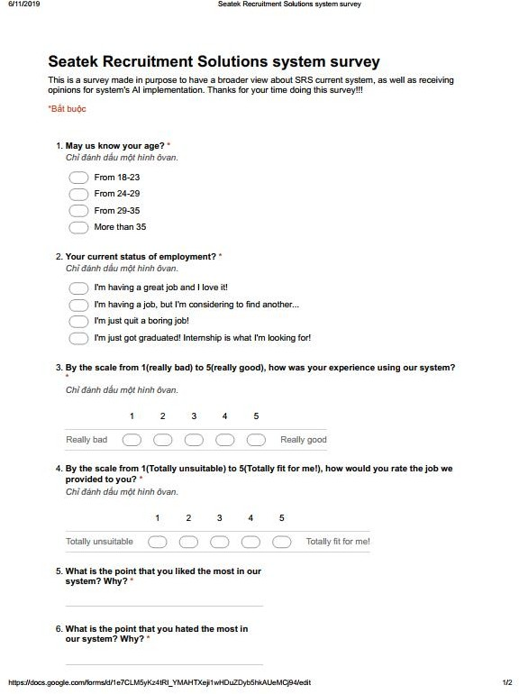

This questionnaire was made to send to the participated/ or participating employees who using or applying to SRS to find their job suggestions. With the data received from the results of this questionnaire, the Research team will have all necessary information from every employee participated to the current system, including:

* + The common, average age of participants (therefore applying to the technologies baseline, since younger employees can be flexible to adapt new technologies)
  + The employment status of participants (therefore can understand participants needs of job)
  + Feedbacks from participants about current Recruitment Solution system (therefore can improve the Job suggestions feature when developing the SRBot)

In conclusion, by applying those two methods in qualitative and quantitative researches, the results gathered will be the main component to make the success of this entire SRBot project, where Project aims and objectives got defined clearly.

### REFERENCES

Project Management Docs. 2019. Project Management Plan Template - Project Management Docs. [ONLINE] Available at: [https://www.projectmanagementdocs.com/template/project-planning/project-](https://www.projectmanagementdocs.com/template/project-planning/project-management-plan/)

[management-plan/.](https://www.projectmanagementdocs.com/template/project-planning/project-management-plan/) [Accessed 11 June 2019].

Management, P., 2017. *A Guide To The Project Management Body Of Knowledge (PMBOK(r) Guide-sixth Edition / Agile Practice Guide Bundle (PMBOK Guide)*. Project Management Institute.